**BUSINESS PLAN**

**INCOME GENERATING ACTIVITY –Vermi-compost**

**by**

**Shiv Shakti- Self Help Group**

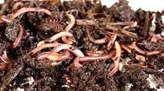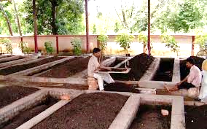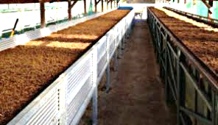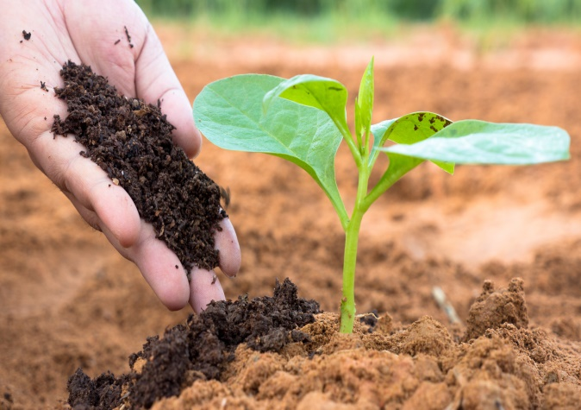

|  |  |  |
| --- | --- | --- |
| SHG/CIG Name | :: | Shiv Shakti |
| VFDS Name | :: | Charain-Mandar |
| Range | :: | Mashobra |
| Division | :: | Shimla |

**Prepared under:**



Project for Improvement of Himachal Pradesh Forest Ecosystems Management & Livelihoods (JICA Assisted)

|  |  |  |
| --- | --- | --- |
| **Sl. No.** | **Particulars** | **Page/s** |
| 1 | Background | 3 |
| 2 | Description of SHG/CIG | 4 |
| 3 | Beneficiaries Detail | 5 |
| 4 | Geographical details of the Village | 6 |
| 5 | Description of product related to Income Generating Activity | 6 |
| 6 | ProductionProcesses | 6-7 |
| 7 | Production Planning | 7 |
| 8 | Sale &Marketing | 7-8 |
| 9 | SWOT Analysis | 8-9 |
| 10 | Description of Management among members | 9 |
| 11 | Description of Economics | 10-11 |
| 12 | Inference of Economic Analysis | 12 |
| 13 | Fund Requirement | 13 |
| 14 | Sources of Fund | 13 |
| 15 | Bank Loan Repayment | 14 |
| 16 | Trainings/capacity Building / Skill up-gradation | 14 |
| 17 | Monitoring Method | 15 |
| 18 | Group Member Photos | 16 |
| 19 | Annexures | 17-19 |

**Table of Contents**

# Background

Vermi-composting has been gaining a strong foothold in the country due to simple production techniques, ecological, economic and human health benefits associated with it. A significant number of vermi-composting units have been set up by entrepreneurs, under government support/ with the technical guidance of Non-Governmental Organizations (NGOs), particularly in the southern and central parts of the country.

Vermi-composting has direct environmental and economic benefits as it contributes to the sustainable agriculture production and income of farmers significantly. There are a number of NGOs, Community Based Organizations (CBOs), Self-Help Groups (SHGs), Trusts etc. which are making concerted efforts to promote vermi-composting technology due to its established economic and environmental advantages.

**Vermi-composting**

Production of compost through rearing/using earth worms is called the vermi-composting technology. Under this technology, earthworms eat biomass and excrete it in a digested form which is known as vermi-composting or vermi-compost. It is one of the simplest and cost effective methods for the production of composting for both the small and large scale farmers. Vermi-compost production unit can be set up in any land which is not under any economic use but shady and free from water stagnation. The site should also be nearer to a water resource

Vermi-composting, rightly called “gold from garbage” is the major input in organic agriculture production. Owing to simple technology, many farmers are engaged in vermi-composting production as it invigorates soil health, soil productivity reduces the cost of cultivation.

There is a gradual increase in demand for vermi-compost due to the high level of nutrient contents.

# Description of SHG/CIG

|  |  |  |
| --- | --- | --- |
| SHG/CIG Name | **::** | Shiv Shakti |
| VFDS | **::** | Charain-Mandar |
| Range | **::** | Mashobra |
| Division | **::** | Shimla |
| Village | **::** | Charain |
| Block | **::** | Mashobra |
| District | **::** | Shimla |
| Total No. of Members in SHG | **::** | 8 |
| Date of formation | **::** | April 2023 |
| Bank a/c No. | **::** | 2583000100048542 |
| Bank Details | **::** | PNB Basantpur |
| SHG/CIG Monthly Saving | **::** | 100/- |
| Total saving |  | 7200/- |
| Total inter-loaning |  | Nil |
| Cash Credit Limit |  | - |
| Repayment Status |  | - |

# Beneficiaries Detail:

|  |  |  |  |  |  |  |
| --- | --- | --- | --- | --- | --- | --- |
| **Sl.**  **No** | **Name** | **Father/ HusbName** | **Age** | **Category** | **Income Source** | **Address** |
| 1 | Nirmala Devi | Sh. Jagdish Chand | 43 | Gen. | Agriculture | Vill. Charain P.O Dabri Teh. & Distt. Shimla |
| 2 | Happy | Sh. Manmohan Singh | 35 | SC | Agriculture | Vill. Charain P.O Dabri Teh. & Distt. Shimla |
| 3 | Sunita Verma | Sh. Nek Chand | 40 | Gen. | Agriculture | Vill. Charain P.O Dabri Teh. & Distt. Shimla |
| 4 | Shanti Devi | Sh. Seeta Ram | 57 | SC | Agriculture | Vill. Charain P.O Dabri Teh. & Distt. Shimla |
| 5 | Nisha Devi | Sh. Yashpal | 35 | Gen. | Agriculture | Vill. Charain P.O Dabri Teh. & Distt. Shimla |
| 6 | Leela Devi | Sh. Madan Singh | 48 | Gen. | Agriculture | Vill. Charain P.O Dabri Teh. & Distt. Shimla |
| 7 | Savitri Devi | Sh. Naresh Kumar | 43 | Gen. | Agriculture | Vill. Charain P.O Dabri Teh. & Distt. Shimla |
| 8 | Santosh | Sh. Gurdeep Kumar | 40 | Gen. | Agriculture | Vill. Charain P.O Dabri Teh. & Distt. Shimla |

# Geographical details of the Village

|  |  |  |  |
| --- | --- | --- | --- |
| 3.1 | Distance from the District HQ | **::** | 55 Km |
| 3.2 | Distance from Main Road | **::** | 10 Km |
| 3.3 | Name of local market & distance | **::** | Basantpur 10km, Sunni 20km |
| 3.4 | Name of main market & distance |  | Sunni 20km, Mashobra 35 km Shimla 55 km |
| 3.5 | Name of main cities & distance |  | Shimla 55 km |
| 3.6 | Name of main cities where product will be sold/ marketed | **::** | Basantpur,Sunni, Mashobra, Shimla |

# Description of Product related to Income Generating Activity

|  |  |  |  |
| --- | --- | --- | --- |
| 4.1 | Name of the Product | **::** | Vermi-composting |
| 4.2 | Method of product identification | **::** | This activity is being already done by some SHG members and has been collectively decided by group members |
| 4.3 | Consent of SHG/ CIG / cluster members | **::** | Yes |

# Description of Production Processes

| **Step** |  | **Description** |
| --- | --- | --- |
| Step-1 | :: | Processing involving collection of wastes, shredding, mechanical separation of the metal, glass and ceramics and storage of organic wastes. |
| Step-2 | :: | Pre digestion of organic waste for twenty days by heaping the material along with cattle dung slurry.  This process partially digests the material and fit for earthworm consumption.  Cattle dung and biogas slurry may be used after drying.  Wet dung should not be used for vermi-compost production. |
| Step-3 | :: | Preparation of earthworm bed. A concrete base is required to put the waste for vermi-compost preparation.  Loose soil will allow the worms to go into soil and also while watering, all the dissolvable nutrients go into the soil along with water. |
| Step-4 | :: | Collection of earthworm after vermi-compost collection.  Sieving the composted material to separate fully composted material.  The partially composted material will be again put into vermi-compost bed. |
| Step-5 | :: | Storing the vermi-compost in proper place to maintain moisture and allow the beneficial microorganisms to grow. |

# Description of Production Planning

|  |  |  |  |
| --- | --- | --- | --- |
| 6.1 | Production Cycle (in days) | **::** | 90 days (three cycles in a year) |
| 6.2 | Manpower required per cycle (No.) | **::** | 1 |
| 6.3 | Source of raw materials | **::** | From household and own farms |
| 6.4 | Source of other resources | **::** | Open market |
| 6.5 | Raw material - quantity required per cycle (Kg) per member | **::** | 3600 Kg per cycle |
| 6.6 | Expected production per cycle (Kg) per member | **::** | 1800Kg per cycle |

# Description of Marketing/ Sale

|  |  |  |  |
| --- | --- | --- | --- |
| 7.1 | Potential market places | **::** | HP Forest Deptt.  Local market  Use on own farm |
| 7.2 | Distance from the unit | **::** |
| 7.3 | Demand of the product in market place/s | **::** | HP Forest deptt is procuring huge vermi-compost for their nursery |
| 7.4 | Process of identification of market | **::** | PMU will facilitate the tie up of procurement of vermi-compost produced by SHG by HP Forest deptt. |
| 7.5 | Marketing Strategy of the product |  | SHG members will also explore the additional marketing options around their villages for better sale price in future. |
| 7.6 | Product branding |  | At CIG/SHG level product will be marketed by branding of respective CIG/SHG. Later this IGA may require branding at cluster level |
| 7.7 | Product “slogan” |  | “Organic” |

# SWOT Analysis

* **Strength**
* Activity is being already done by some SHG members
* Each of the SHG members are having cattle varying from 2 to 8 in each household
* Families of SHG members are cultivating high value crops & vegetables which offers adequate availability of raw materials i.e. farm organic wastes throughout the year.
* Raw material easily available at their farms
* Manufacturing process is simple
* Proper packing and easy to transport
* Other family members will also cooperate with beneficiaries
* Product self-life is long
* **Weakness**
* Effect of temperature, humidity, moisture on manufacturing process/product.
* Lack of technical know-how
* **Opportunity**
* Increasing demand of vermi-compost on account of awareness among farmers about organic and natural farming
* Application of vermi-compost on their own field will go a long way in improving and enhancing the soil health and production of quality farm produce which will offer better price.
* Best utilization of organic waste including household left outs of kitchens
* Potential for marketing tie up with HP Forest
* **Threats/Risks**
* Possibility of break of production cycle due to extreme weather
* Competitive market
* Level of commitment among beneficiaries towards participation in training/ capacity building & skill up-gradation

# Description of Management among Members

* **Production –** It will be taken care of by individual members including procurement of raw materials
* **Quality assurance –** Collectively
* **Cleaning & packaging –** Collectively
* **Marketing –** Collectively
* **Monitoring of the unit -** Collectively

# Description of Economics

(Amount in actual Rs.)

|  |  |  |  |  |  |  |  |  |  |
| --- | --- | --- | --- | --- | --- | --- | --- | --- | --- |
| **S. No** | **Particulars** | **Units** | **Quantity / Nos.** | **Cost (Rs.)** | **Year 1** | **Year 2** | **Year 3** | **Year 4** | **Year 5** |
|  | **Capital Cost** |  |  |  |  |  |  |  |  |
| 1 | Preparation of Earth worm Bed(Bed Size 10ftX10ft ) | Per member | 8 | 6000 | 48000 | 0 | 0 | 0 | 0 |
| 2 | Wire Mesh 3x3 mm (4’x3’ sieve) | Per member | 8 | 500 | 4000 | 0 | 0 | 0 | 0 |
| 3 | Weighing scale etc. | Per member | 8 | 1000 | 8000 | 0 | 0 | 0 | 0 |
|  | **Total Capital Costs** |  |  |  | **60000** |  |  |  |  |
| **B** | **Recurring Costs** |  |  |  |  |  |  |  |  |
| 4 | Seed earthworm | 5 kg per member | 40 | 500 | 20000 | 0 | 0 | 0 | 0 |
| 5 | Cost of procurement of Slurry/dung/waste | Tonnes | 108 | 900 | 97200 | 102060 | 107163 | 112521 | 118147 |
| 6 | Labour Cost | Per tonne | 54 | 700 | 37800 | 39690 | 41674 | 43757 | 45945 |
| 7 | Packing materials | No. | 8000 | 2 | 16000 | 16800 | 17640 | 18522 | 19448 |
| 8 | Other handling charges | Per tonne | 54 | 150 | 8100 | 8505 | 8930 | 9376 | 9845 |
| **C** | **Other charges** |  |  |  |  |  |  |  |  |
| 9 | Insurance | L/S |  |  | 0 | 0 | 0 | 0 | 0 |
| 10 | Interest on loan | Per annum |  | 2 per cent | 6000 | 6000 | 6000 | 6000 | 6000 |
|  | **Total recurring costs** |  |  |  | **185100** | **173055** | **181407** | **190176** | **199385** |
|  | **Total cost = Capital and recurring** |  |  |  | **245100** | **173055** | **181407** | **190176** | **199385** |
| **D** | **Income from vermicomposting** |  |  |  |  |  |  |  |  |
| 11 | **Sale of vermi-compost** | Tonnes | 54 | **6000** | **324000** | **340200** | **357210** | **375070** | **393823** |
| 12 | **Sale of earthworm** |  |  |  |  | **10000** | **20000** | **20000** | **20000** |
| 13 | **Total revenue** |  |  |  | **324000** | **354200** | **377210** | **395070** | **413823** |
| 14 | Net returns (D-C) |  |  |  | **138900** | **181145** | **195803** | **204894** | **214438** |

**Note**– As labour work will be done by SHG members themselves and Slurry/dung/waste already available at their place and these materials will be not procured by them, therefore, recurring cost (Labour Cost, Cost of procurement of Slurry/dung/waste) can be deducted from total recurring cost.

**Economic Analysis**

|  |  |  |  |  |  |  |
| --- | --- | --- | --- | --- | --- | --- |
| **S. No** | **Particulars** | **Year 1** | **Year 2** | **Year 3** | **Year 4** | **Year 5** |
| **1** | Capital cost | **60000** | **0** | **0** | **0** | **0** |
| 2 | Recurring cost | **185100** | **173055** | **181407** | **190176** | **199385** |
| 3 | Total cost | **245100** | **173055** | **181407** | **190176** | **199385** |
| 4 | Total benefits | **324000** | **354200** | **377210** | **395070** | **413823** |
| **5** | **Net benefits** | **78900** | **181145** | **195803** | **204894** | **214438** |

**Distribution of net profit -** As per share in production.

# Inferences of Economic Analysis

* Pit size for each member has been planned at 10X10ft .
* Cost of production of vermi-compost comes to Rs. 3.5 per Kg
* Sale of vermi-compost (conservative side) is Rs. 6 per Kg
* Net profit will be Rs. 2.5 per Kg
* It is proposed that each member will produce 5.4 tonnes of vermi-compost every year resulting in production of 54 tonnes vermi-compost by all 10 members of SHG in one year.
* Cost of earthworm has been kept at Rs. 500.00 per kg
* During second year onwards, there will be surplus earthwork for sale (as it will multiply during the process of production of vermi-compost)
* The vermi-compost making is a profitable IGA and can be taken up by the SHG members.

# Fund requirement:

|  |  |  |  |  |
| --- | --- | --- | --- | --- |
| **Sl. No.** | **Particulars** | **Total Amount (Rs)** | **Project support** | **SHG contribution** |
| 1 | Total capital cost | 60000 | 45000 | 15000 |
| 2 | Total Recurring Cost | 185100 | 0 | 185100 |
| 3 | Trainings/ capacity building/skill up-gradation | 50000 | 50000 | 0 |
|  | **Total =** | **295100** | **95000** | **200100** |

# Note-

# Capital Cost - 75% of capital cost to be covered under the Project

# Recurring Cost - To be borne by the SHG/CIG.

# Trainings/capacity building/ skill up-gradation - To be borne by the Project

# Sources of fund:

|  |  |  |
| --- | --- | --- |
| Project support; | 75% of capital cost will be utilized for construction of pit and shed (Size will be of 10ftX4ftX2ft )UptoRs 1 lakh will be parked in the SHG bank account.Trainings/capacity building/ skill up-gradation cost.The subsidy of 5% interest rate will be deposited directly to the Bank/Financial Institution by DMU and this facility will be only for three years. SHG have to pay the installments of the Principal amount on regular basis. | Procurement of materials/constructionwill be done by respective DMU/FCCU after following all codal formalities. |
| SHG contribution | 25% of capital cost to be borne by SHG.Recurring cost to be borne by SHG |  |

# Bank loan repayment

If the loan is availed from bank it will be in the form of cash credit limit and for CCL there is not repayment schedule; however, the monthly saving and repayment receipt from members should be routed through CCL.

* In CCL, the principal loan outstanding of the SHG must be fully paid to the banks once a year. The interest amount should be paid on a monthly basis.
* In term loans, the repayment must be made as per the repayment schedule in the banks.
* Project support - The subsidy of 5% interest rate will be deposited directly to the Bank/Financial Institution by DMU and this facility will be only for three years. SHG/CIG have to pay the installments of the Principal amount on regular basis

# Trainings/Capacity Building/Skill Up-gradation

Trainings/capacity building/ skill up-gradation cost will be borne by project.

Following are some trainings/capacity building/ skill up-gradation proposed/needed:

* Project Orientation Group Formation/ Reorganization
* Group Concept and Management
* Introduction to IGA (General)
* Marketing and Business Plan Development
* Bank Credit Linkages & Enterprise Development
* Exposure Visit of SHGs/ CIGs – Within the State& Outside State

# Monitoring Mechanism

* Social Audit Committee of the VFDS will monitor the progress and performance of the IGA and suggest corrective action if need be to ensure operation of the unit as per projection.
* SHG should also review the progress and performance of the IGA of each member and suggest corrective action if need be to ensure operation of the unit as per projection.

**Group members Photo –**

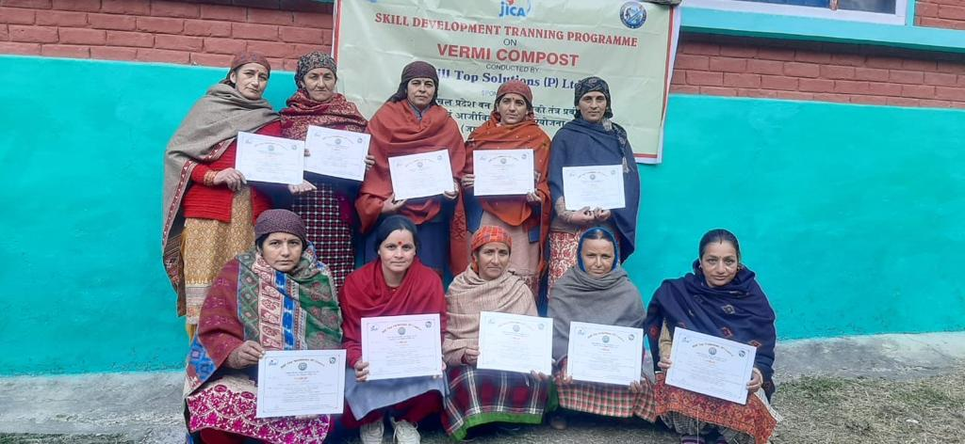

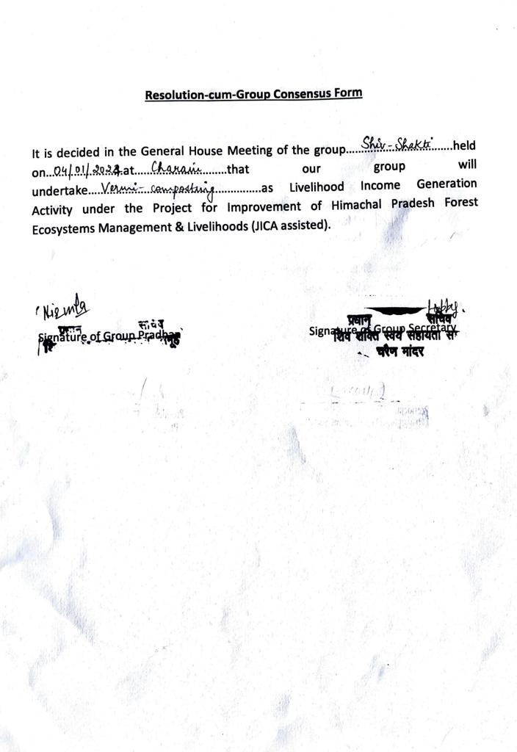

**Annexure I**

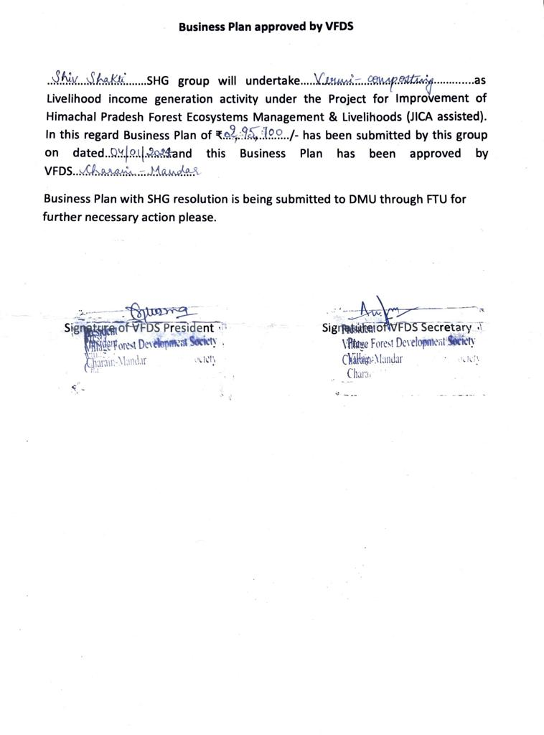

**Annexure II**

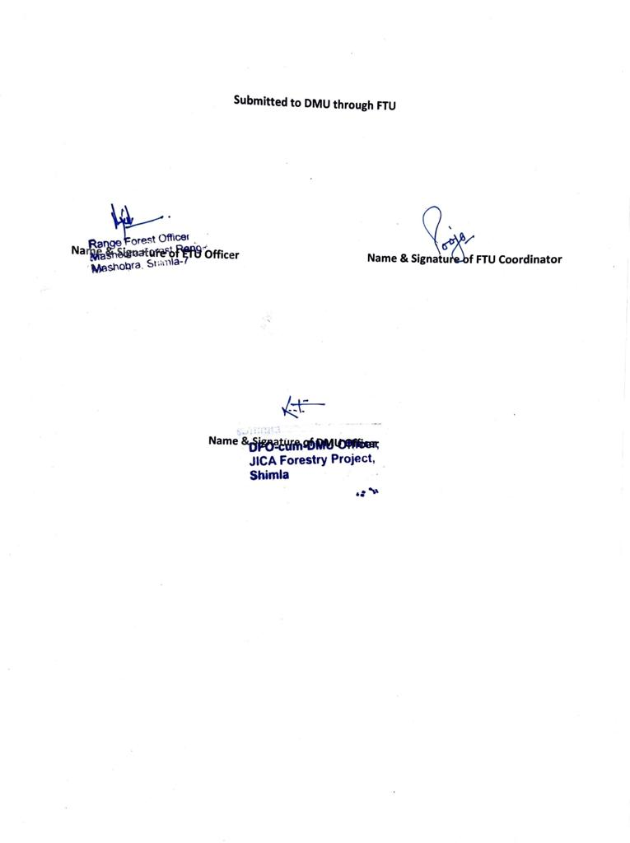

**Annexure III**